Stakeholder & Supporter Toolkit

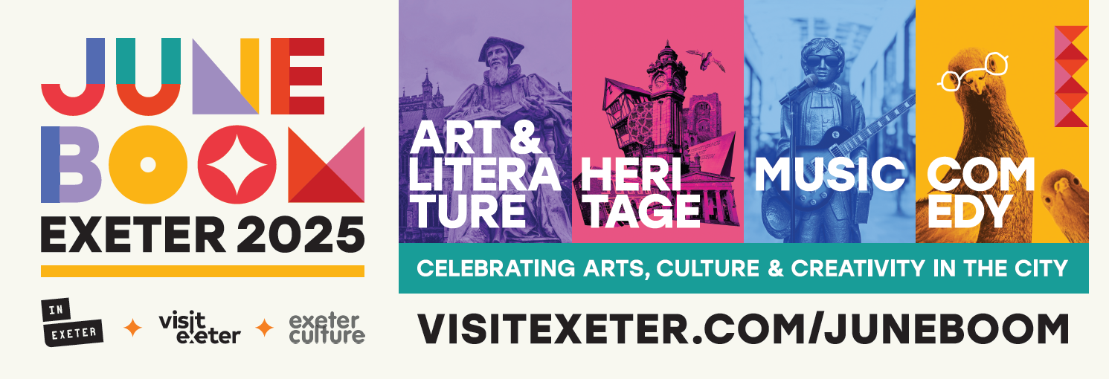

## Get Ready for June Boom: Exeter’s Month of Culture, Comedy, Music and More! Exeter is set for an unforgettable June as the **city comes alive** with June Boom — a month-long celebration packed with **vibrant events, arts, culture,** and **entertainment**. From **live music** and laugh-out-loud comedy to inspiring heritage festivals and creative arts and literature events, there’s something for everyone and **we need *your* help spreading the word** so nobody misses a thing. This pack includes everything you need to support the June Boom campaign to help spread the word!

**June Boom Webpage:** [**www.visitexeter.com/juneboom**](http://www.visitexeter.com/juneboom)

# **We have a library of assets you are welcome to make use of. Please see:** [June Boom Asset Library](https://drive.google.com/drive/folders/1xEzZ_Qt3znqyC-YjH18kBHDQIKBUYpa4?usp=sharing)

## **Social posts**

We have the following assets available for you to use on social media:

* **Animated Video**
* **Square posts:**

* **1080 x 1350 posts:**

**The following copy is available for you to use to accompany posts:**

**Instagram and Facebook:**

🎉 Get Ready for June Boom: Exeter’s Month of Culture, Comedy, Music & More! 🎭🎶📚

Exeter is gearing up for a spectacular June as June Boom brings the city to life — a month-long celebration of live music, big laughs, brilliant festivals, creative workshops, and cultural events across the city.

Whether you’re into live gigs, laugh-out-loud comedy, hands-on activities or exploring the city’s rich heritage, there’s plenty to enjoy.

Plan your June in Exeter: visitexeter.com/juneboom — what will you discover?

#JuneBoom #Exeter #InExeter #VisitExeter #ExeterCulture

**X and Threads:**

🎉 June Boom is coming! Exeter’s packed with music, comedy, festivals, workshops & more all month long.

Explore what’s on and plan your June: [visitexeter.com/juneboom](https://visitexeter.com/juneboom)

#JuneBoom #Exeter #InExeter #VisitExeter #ExeterCulture

## **Press release copy**

If you are releasing your own press release and want to highlight June Boom within your press release you can use the following information:  
  
[Insert your event name here] is one of many events being put on by cultural producers within Exeter this June. June Boom is a month-long celebration packed with vibrant events, arts, culture, and entertainment.

From live music and laugh-out-loud comedy to inspiring heritage festivals and creative arts and literature events, **there’s something for everyone** — and you won’t want to miss a thing.

Quotes available to be included:

* **Nicola Wheeler, CEO at InExeter, says:**"*Exeter is already an amazing place to visit, but this June, it’s going to be buzzing! We’re shouting from the rooftops so no one misses out. From live music and comedy to vibrant community festivals, Exeter has it all. We encourage everyone to explore and discover all the exciting events happening this June in the city!”*
* **Councillor Bob Foale, Lead Councillor for Arts, Culture and Tourism, Exeter City, says:***“Exeter offers a huge variety of events throughout the year, and we are proud to highlight just some of these during June Boom. Whether you live in Exeter or are visiting our city, take a look at the programme as there is something for all ages and interests and you might discover something new.”*

**Notes to editors for the bottom of the press release:**  
  
**June Boom**

June Boom is a coordinated campaign between InExeter, Exeter Culture and Visit Exeter to amplify all the amazing events happening in June in Exeter city centre, celebrating all the fantastic work by cultural producers and shining a spotlight on events venues within Exeter.[www.visitexeter.com/juneboom](http://www.visitexeter.com/juneboom)

## **Posters**

We have the following posters available in A4 and A3 formats – please contact us via email to request posters: [info@inexeter.com](mailto:info@inexeter.com).

## **A5 Leaflet**

We have A5 leaflets available – if you would like to display at your event or venue please request: [info@inexeter.com](mailto:info@inexeter.com). These will be available on a first come, first-served basis.

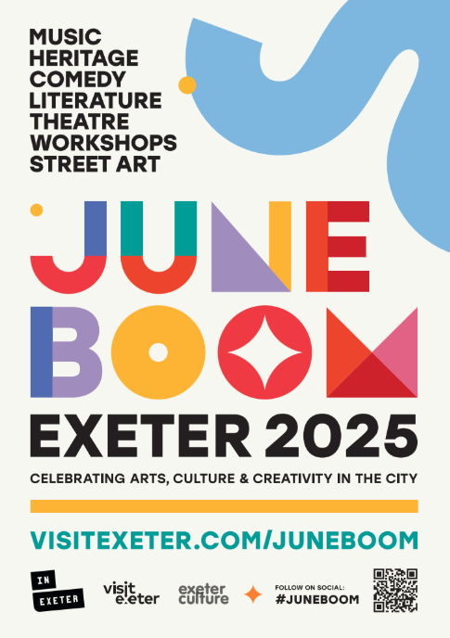**

## **Post card**

We have A6 leaflets available – if you would like to display at your event or venue please request: [info@inexeter.com](mailto:info@inexeter.com). These will be available on a first come, first-served basis.

**Thank you for taking part in June Boom. If you require any further information on this campaign, please do get in touch:**

**Alice Evans**InExeter Marketing Manager

[alice@inexeter.com](mailto:alice@inexeter.com)

